**ASSISTED LABS**

* 1. **SET UP AND CREATING A NEW REPOSITORY**

1. Installation git from chrome browser
2. Executing some basic commands

**COMMANDS:**

$git version

$git clone <https://github.com/KarakambadiNaveena/dotnet>

$git config –global --list

$ls -al

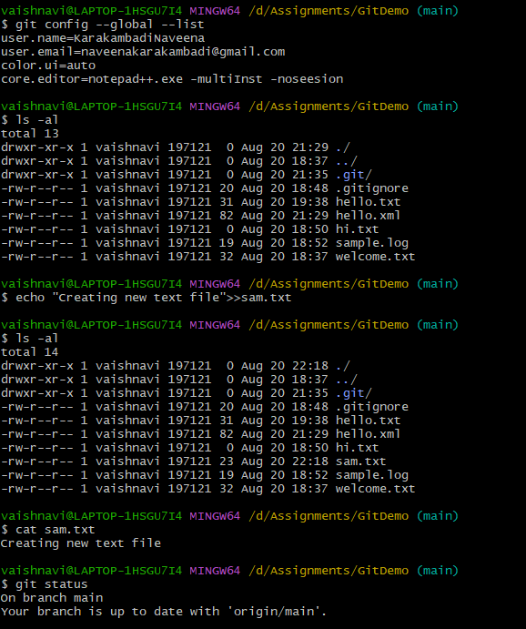

$ echo "Creating new text file">>sam.txt

$ git status

$ git add .

$ git commit -m "firstcommit"

$git push origin main

$ git pull origin main

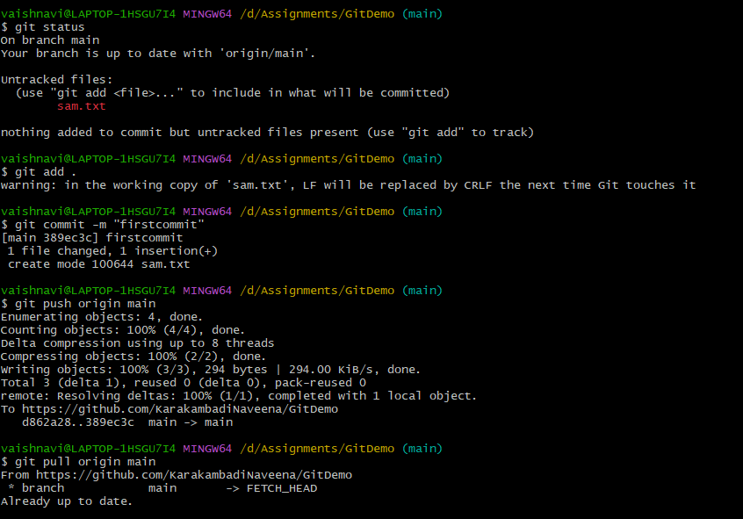

* 1. **CRUD OPERATIONS ON GIT**

**Step 1.2.1:** Reverting the previous commits

git log.

git log - -online

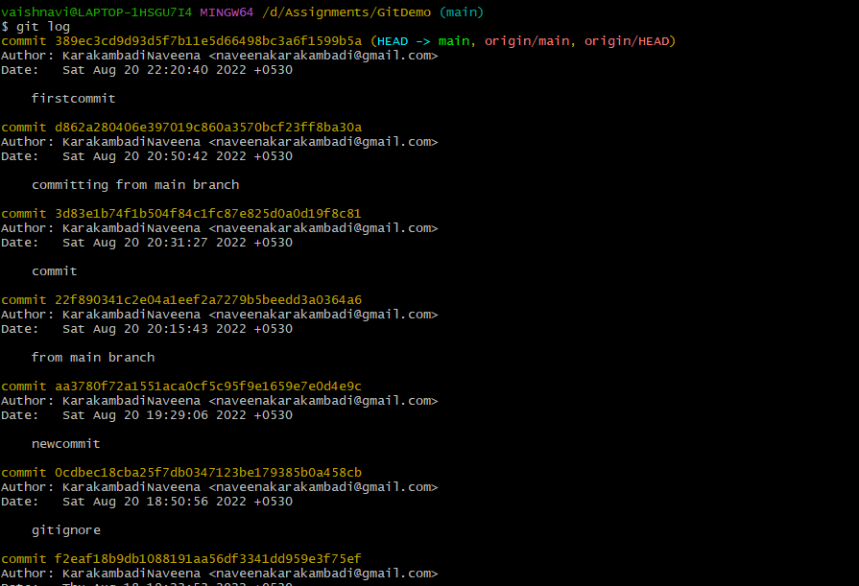

git revert 389ec3c

git checkout main

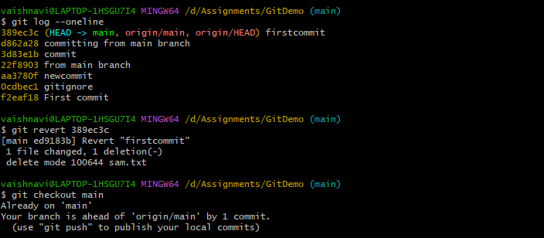

**Step 1.2.2:** Ignoring specific files from the.git directory

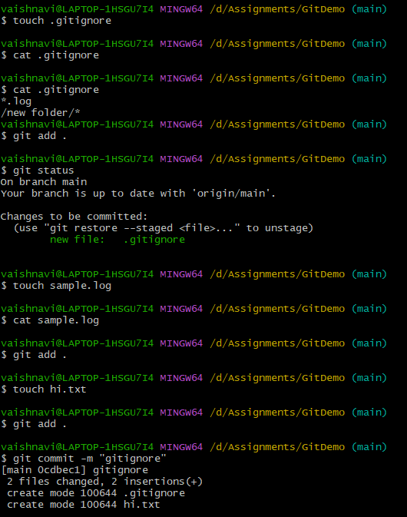

**COMMANDS:**

git status

git push origin main

git pull origin main

git merge

git pull –verbose

git log –oneline

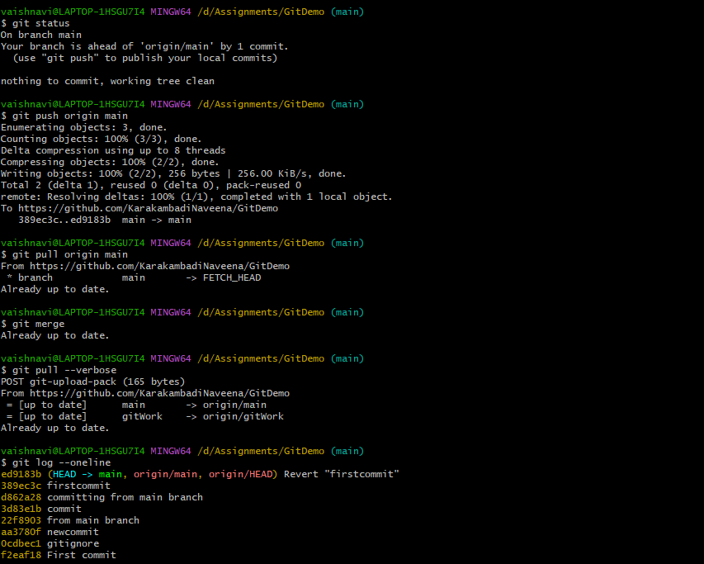

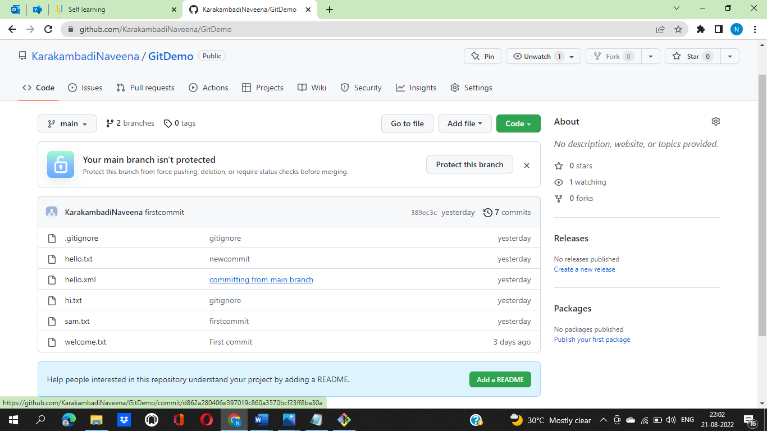

**1.3 Setup and configuring GitHub account**

**Step 1.3.1:** Setting up your GitHub account

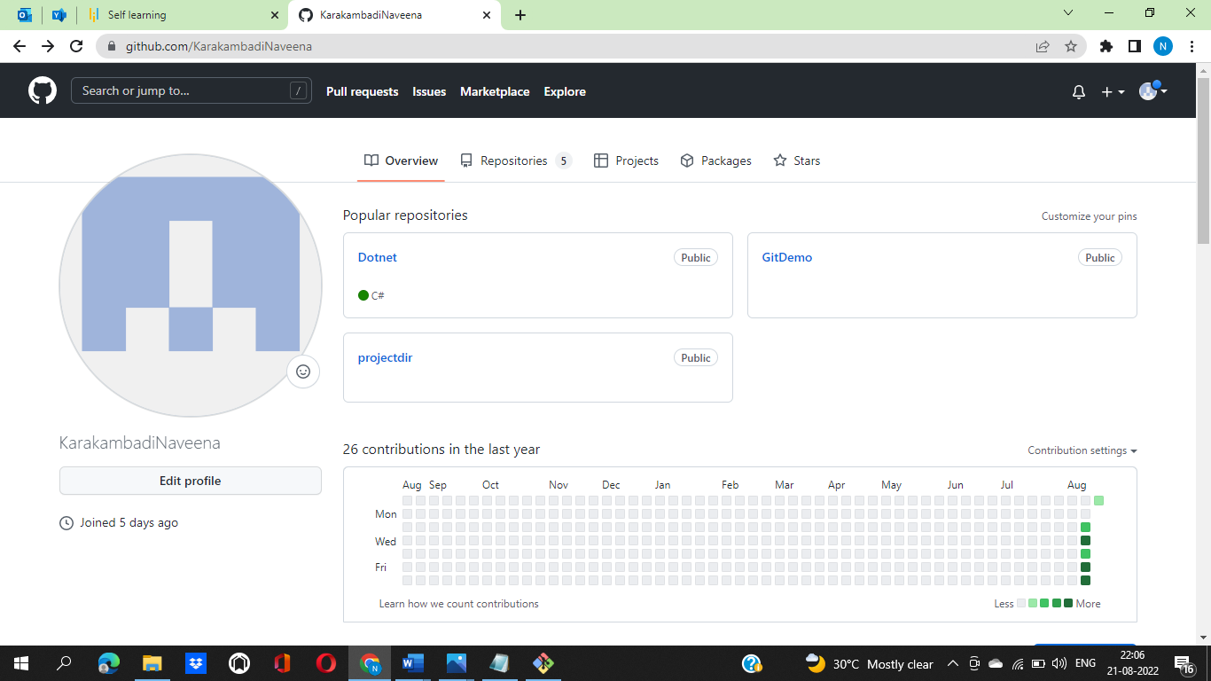

2.Creating a repository in your GitHub account.

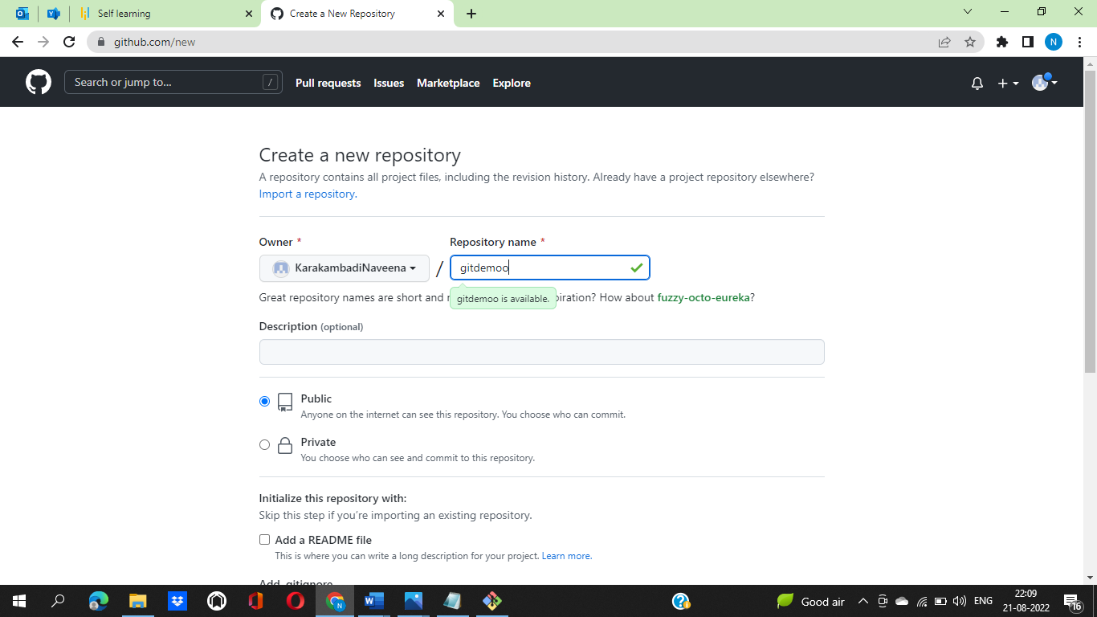

3.Creating an SSH Key and adding it to GitHub

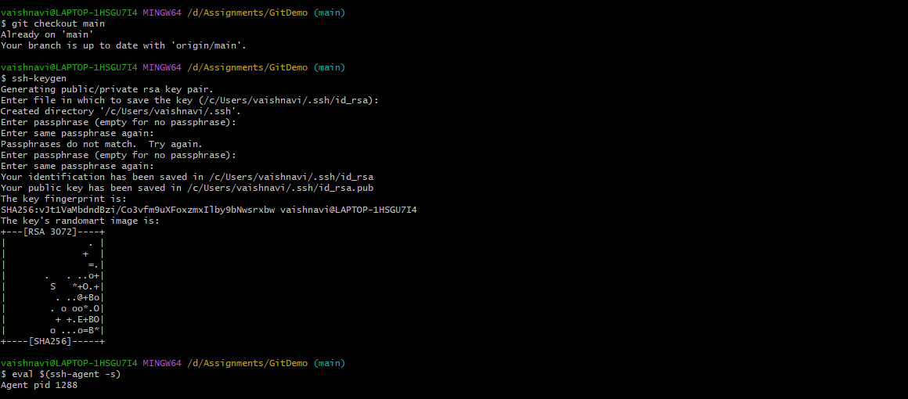

1. Logging at local Git to connect with remote GitHub.

